Day 1 - 16th May 2025

Your Doc name:

Day 1 - 113312696- Aditya Shubham

SDLC:

Task: 1
What is SDLC?

SDLC is a structured process to design, develop, test, and deploy software. It provides a framework with defined phases to ensure efficiency, cost-effectiveness, and the delivery of a product that meets customer requirements.

5 min 10.10 to 10.15

Task 2:
Why is SDLC ?

- Ensures Systematic & Organized Development
- Improves Software Quality
- Reduces Risks and Costs
- Enhances Customer Satisfaction
- Provides Better Project Management
- Ensures Scalability & Maintainability
- Compliance & Security
- Supports Different Development Models

5 min 10.20 to 10.25

What are the stages of SDLC ? write 2 lines about each.

SDLC Phases
- Planning & Requirement Analysis- Define project scope, objectives, and feasibility
- System Design- Define architecture and specifications before coding
- Implementation- Develop the software based on design documents
- Testing- Identify and fix defects before deployment
- Deployment- Release he software to users
- Maintenance & Support- Ensure smooth operation and updates

Task 4:

SDLC Models:
List them , description - 4 lines min and with a image

SDLC Models

- Waterfall Model- Sequential linear approach
  - Each stage must be completed before moving to the next.
  - Planning & Requirements -> Design -> Implementation -> Testing -> Deployment -> Maintenance
  - Short, well defined-projects
  - Simple and easy to manage, good documentation
  - No flexibility for changes, testing happens late (high risk of failure)
  - e.g.Building a Banking System (ATM Software, transaction processing)
  - Requirements are fixed, compliance is critical. E.g. Microsoft early Windows releases

- Agile Model- Iterative, flexible development
  - Delivers software in small increments (usually 2-4 weeks sprints)
  - Scrum (Sprint planning, daily standups, retrospective)
  - Kanban (Continuous flow, visual task boards)
  - Dynamic requirements, need for frequent customer feedbacks
  - Adaptable to change, faster way of working software
  - Requires high customer involvement, less predictable timeline/budget
  - E.g. Mobile App Development, frequent updates based on user feedback
  - Spotify uses Agile

- DevOps- Combines development and operations for continuous delivery
  - Continuous Integration (CI) -> Continuous Development (CD) -> Monitoring
  - Cloud-based scalable application. Frequent updates (e.g. SaaS products)
  - Faster releases, automations reduces errors
  - Require cultural shift in teams, high initial setup costs.

- Spiral Model- Combines waterfall + Iterative Development
  - Planning -> Risk analysis -> Development -> Evaluation (repeats in cycles)
  - High-risk, complex projects, long-term projects with evolving requirements
  - Expensive (requires frequent evaluation)
- V-Model (Verification & Validation Model): Extension of Waterfall with testing each stage
  - Each development phase has a corresponding testing phase.
  - Requirements -> System testing
  - Design-> Integration testing
  - Coding -> Unit Testing
  - Mission-critical systems (e.g. medical, aerospace). High-reliability requirements.
  - Early defect detection, structured and disciplined.
  - Rigid (hard to accommodate changes, time-consuming)

- Iterative Model: Builds Software in Repeated Cycles
  - Start with a simple version -> Enhance in iterations
  - Large projects where requirements evolve. Early user feedback is needed
  - Reduces initial delivery risk, flexible for changes
  - Can be costly if iterations are uncontrolled

What is a Scrum?

What is a sprint?

A short time for which all the product development process is done

Sprint are block of subtasks that are done have got its specific time limit

Task 9: Do's and Don'ts of Sprint (3 points each)

Do's:
1. Follow sprint planning and stick to committed tasks
2. Attend all sprint ceremonies (standups, reviews, retrospectives)
3. Maintain transparency and regular communication

Don'ts:
1. Change sprint scope mid-sprint or add new requirements
2. Skip important meetings or work in isolation
3. Overcommit or take more than capacity

Task 10: Stories and Backlogs in Scrum

User Stories:
- Brief descriptions of functionality from user's perspective
- Follow format: "As a [user], I want [goal] so that [benefit]"
- Should be independent, negotiable, valuable, estimable, small, and testable

Backlogs:
- Prioritized list of all required work
- Contains user stories, bugs, technical tasks
- Dynamic and regularly refined
- Owned by Product Owner
- Constantly evolving based on business needs

Task 11: Scrum Artifacts

1. Product Backlog:
- Complete list of all desired product features
- Prioritized by Product Owner
- Dynamic and continuously updated
- Contains epics, stories, bugs, technical debt

2. Sprint Backlog:
- Subset of Product Backlog items selected for current sprint
- Detailed plan for delivering increment
- Owned by Development Team
- Updated daily during sprint

3. Burn-Down Chart:
- Visual representation of work remaining vs time
- Shows sprint progress
- Updated daily
- Helps identify if team is on track

4. Increment:
- Sum of all completed Product Backlog items
- Must be "Done" as per Definition of Done
- Should be potentially releasable
- Represents value delivered to stakeholders

Task 10: Stories and Backlogs in Scrum
User Stories:
- Brief descriptions of functionality from user's perspective
- Follow format: "As a [user], I want [goal] so that [benefit]"
- Should be independent, negotiable, valuable, estimable, small, and testable
Backlogs:
- Prioritized list of all required work
- Contains user stories, bugs, technical tasks
- Dynamic and regularly refined
- Owned by Product Owner
- Constantly evolving based on business needs
Task 11: Scrum Artifacts
- Product Backlog:
- Complete list of all desired product features
- Prioritized by Product Owner
- Dynamic and continuously updated
- Contains epics, stories, bugs, technical debt
- Sprint Backlog:
- Subset of Product Backlog items selected for current sprint
- Detailed plan for delivering increment
- Owned by Development Team
- Updated daily during sprint
- Burn-Down Chart:
- Visual representation of work remaining vs time
- Shows sprint progress
- Updated daily
- Helps identify if team is on track
- Increment:
- Sum of all completed Product Backlog items
- Must be "Done" as per Definition of Done
- Should be potentially releasable
- Represents value delivered to stakeholders
Task 12: Ports and Protocols

PORTS:
- Virtual endpoints for network communications
- Numbers ranging from 0 to 65535
- Divided into categories:
* Well-known ports (0-1023)
* Registered ports (1024-49151)
* Dynamic ports (49152-65535)

Common Well-Known Ports:
1. HTTP: Port 80
2. HTTPS: Port 443
3. FTP: Port 21
4. SSH: Port 22
5. SMTP: Port 25
6. DNS: Port 53
7. Telnet: Port 23

PROTOCOLS:
1. TCP (Transmission Control Protocol)
- Connection-oriented
- Reliable data delivery
- Used for: Email, web browsing, file transfer

2. UDP (User Datagram Protocol)
- Connectionless
- Faster but less reliable
- Used for: Streaming, gaming, DNS

3. HTTP/HTTPS
- Web communication
- HTTPS is secure version with encryption

4. FTP (File Transfer Protocol)
- File transfer between client and server

5. SSH (Secure Shell)
- Secure remote access
- Encrypted communications

6. SMTP (Simple Mail Transfer Protocol)
- Email transmission

7. DNS (Domain Name System)
- Domain name resolution to IP addresses

Remember: Port + Protocol combinations enable specific types of network communications and services.

Task 13: Different Network Types

1. PAN (Personal Area Network)
- Smallest network type
- Range: Few meters
- Examples: Bluetooth devices, wireless headphones
- Used for personal device connections

2. LAN (Local Area Network)
- Limited geographical area (building/campus)
- High data transfer speeds
- Common in offices, schools, homes
- Usually connected via Ethernet or Wi-Fi

3. MAN (Metropolitan Area Network)
- Covers a city or large campus
- Larger than LAN, smaller than WAN
- Examples: Cable TV networks, city-wide networks
- Connects multiple LANs

4. WAN (Wide Area Network)
- Spans large geographical areas
- Connects multiple LANs/MANs
- Example: Internet
- Uses telecommunication lines

5. WLAN (Wireless Local Area Network)
- Wireless version of LAN
- Uses Wi-Fi technology
- No physical cable connections
- Common in homes and offices

6. CAN (Campus Area Network)
- University/corporate campus networks
- Connects multiple buildings
- Combination of various network types

7. SAN (Storage Area Network)
- Dedicated network for storage devices
- High-speed data transfer
- Used in data centers
- Specialized for data storage/backup

8. VPN (Virtual Private Network)
- Creates secure connection over public network
- Encrypts data transmission
- Provides remote access
- Ensures privacy and security

Each network type serves specific purposes and has distinct characteristics in terms of:
- Geographic scope
- Speed
- Security
- Purpose
- Infrastructure requirements

Task 14: Types of Servers

1. Web Server
- Hosts websites and web applications
- Handles HTTP/HTTPS requests (Apache, Nginx)
- Delivers web content to browsers

2. Database Server
- Stores and manages databases
- Handles data queries and updates
- Examples: MySQL, PostgreSQL, MongoDB

3. File Server
- Centralizes file storage and sharing
- Manages access permissions
- Common in corporate environments

4. Mail Server
- Handles email sending/receiving
- Manages email accounts and routing
- Examples: Microsoft Exchange, Postfix

5. Application Server
- Hosts applications and business logic
- Connects web and database servers
- Examples: Tomcat, JBoss, WebLogic

6. DNS Server
- Resolves domain names to IP addresses
- Maintains DNS records
- Critical for internet navigation

7. Proxy Server
- Acts as intermediary between users and internet
- Provides caching and filtering
- Enhances security and performance

8. FTP Server
- Manages file transfers
- Provides file upload/download services
- Controls file access permissions

Task 15: DNS (Domain Name System)

1. Purpose:
- Translates domain names to IP addresses
- Makes internet navigation user-friendly
- Works like a phone book for the internet

2. DNS Hierarchy:
- Root Domain (.)
- Top-Level Domains (com, org, net)
- Second-Level Domains (google, amazon)
- Subdomains (mail, www)

3. Key Components:
- DNS Servers
- DNS Records (A, MX, CNAME, etc.)
- DNS Cache
- DNS Resolvers

4. DNS Resolution Process:
- User enters domain name
- Local DNS cache check
- Query to DNS resolver
- Recursive search through DNS hierarchy
- Returns IP address to user

5. Common DNS Record Types:
- A Record (IPv4 address)
- AAAA Record (IPv6 address)
- MX Record (mail servers)
- CNAME (aliases)
- NS Record (nameservers)
What are the different Network Topologies?

Network Topology is the physical or logical arrangement of network devices and their interconnections in a computer network. It defines how different nodes (computers, servers, switches, etc.) are connected and how they communicate with each other.

Types include Bus, Star, Ring, Mesh, Tree, Hybrid, and Point-to-Point, each having unique characteristics and use cases suitable for different network requirements.
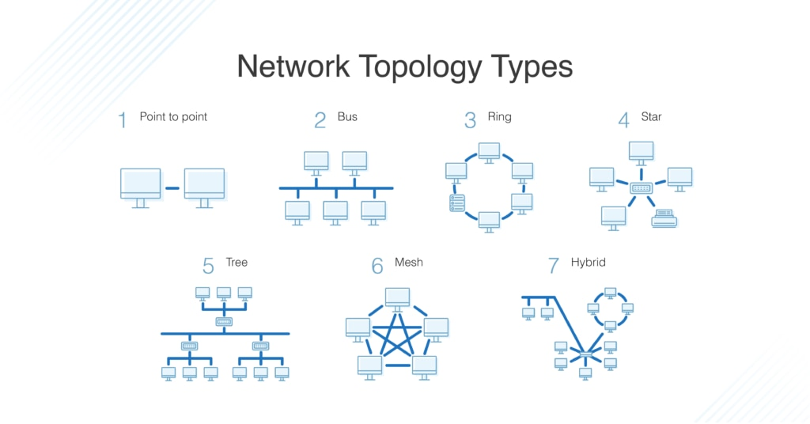

What is OSI Model ?
Describe the 7 layers with description.

OSI Model: A conceptual framework that standardizes the functions of a telecommunication/computing system into seven abstraction layers for network communication.

The 7 Layers (Top to Bottom):

7. Application Layer
- Directly interacts with user applications
- Examples: HTTP, FTP, SMTP, DNS

6. Presentation Layer
- Data formatting and encryption
- Handles data translation and encryption

5. Session Layer
- Manages connections between applications
- Controls authentication and session restoration

4. Transport Layer
- End-to-end delivery and error checking
- TCP/UDP protocols operate here

3. Network Layer
- Routes data packets between networks
- IP addressing and path determination

2. Data Link Layer
- Node-to-node delivery and error detection
- MAC addressing and frame synchronization

1. Physical Layer
- Raw bit transmission over physical medium
- Handles cables, switches, and physical topology

